**DOCTYPE**

不加，browser仍然可以display the page。

加會幫助browser correctly render the page (with CSS,…)，

且這種作法較為正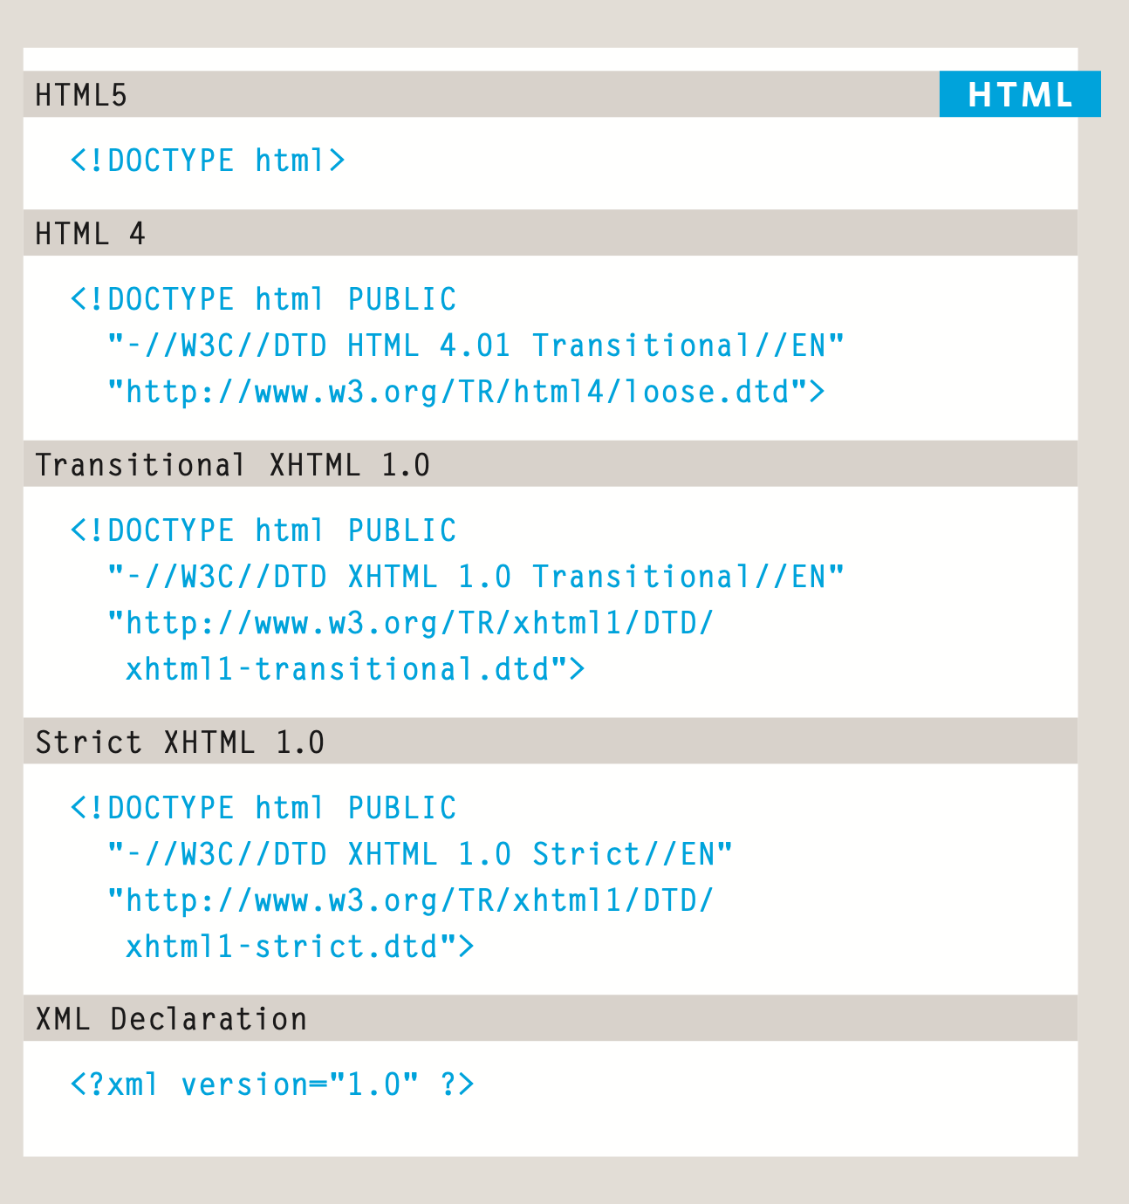

**Comments**

在<!-- 和--> 之間的任何文字都不會被顯示在html rendering上。

很長的webpages常常需要comments，不只可以記下重點也可以達到分開source code的sections的效果，增加readability。

<!-- end of main text -->

<!--

<a href="mailto:info@example.org">Contact</a> -->

**ID**

Uniquely identify the element from all the other instances of the same element, so we can stylize the element differently.

It’s important that no 2 elements on the same webpage have the same id

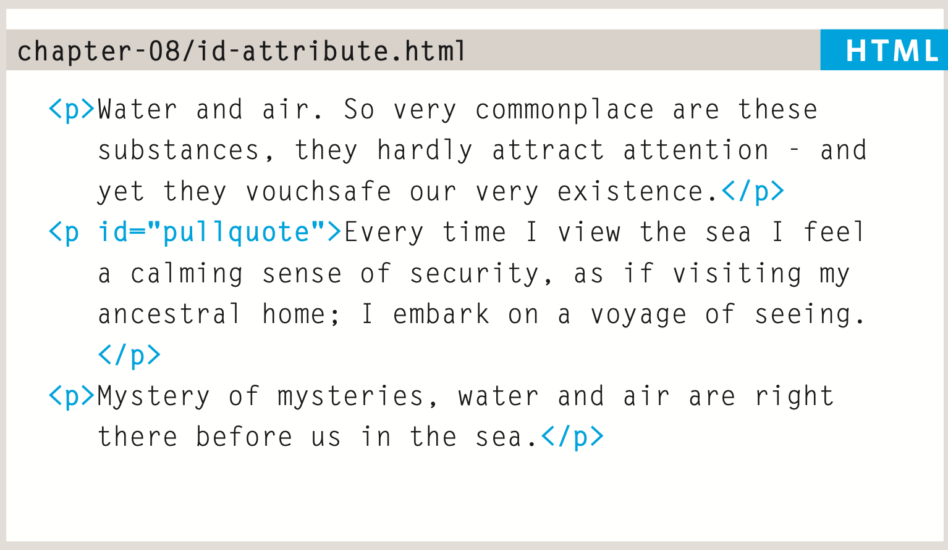

**Class**

假設我們不只想要stylize “one” particular element but a group of particular elements, we can use a class to group them together.

<p class="important admittance">

代表該段落擁有兩個class屬性（important 和admittance），以空格隔開。

但要specify their style, CSS rules must be applied.

<p class="important">For a one-year period from November 2010, the Marugame Genichiro-Inokuma Museum of Contemporary Art (MIMOCA) will host a cycle of four Hiroshi Sugimoto exhibitions.</p>

<p>Each will showcase works by the artist thematically contextualized under the headings "Science," "Architecture," "History" and "Religion" so as to present a comprehensive panorama of the artist's oeuvre.</p>

<p class="important admittance">Hours: 10:00 – 18:00 (No admittance after 17:30)</p>

**Block elements**

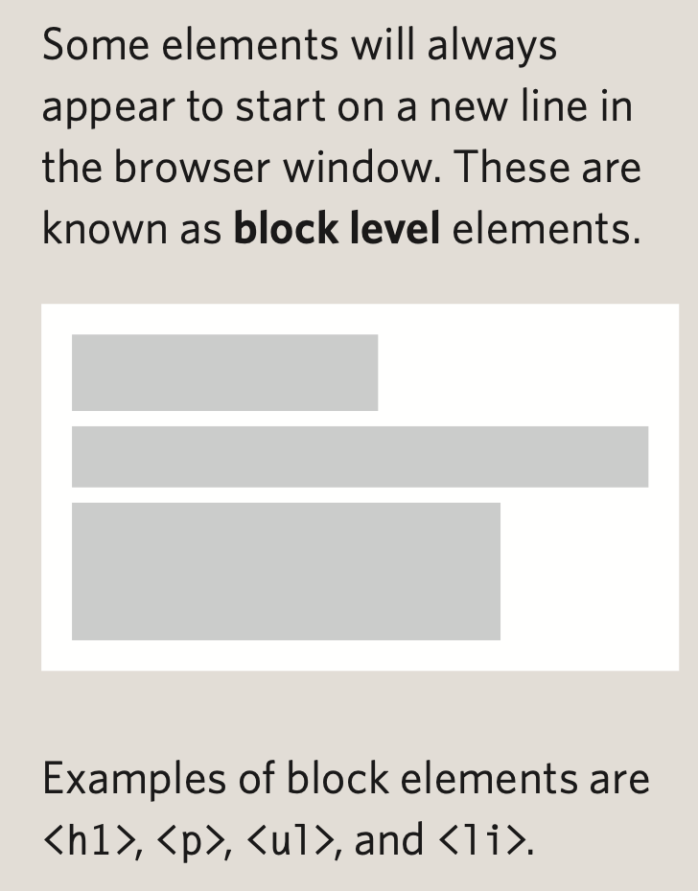

**<div>**